http://www.newyorker.com/culture/cultural-comment/poetry-in-a-time-of-protest

CULTURAL COMMENT

POETRY IN A TIME OF PROTEST

By Edwidge Danticat
January 31, 2017

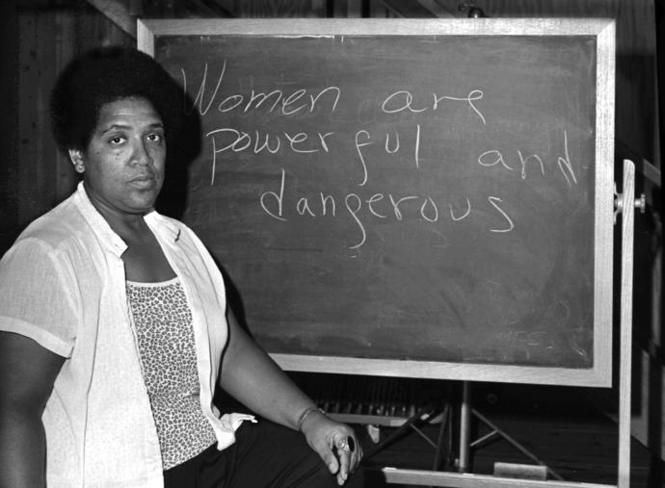
The poet and activist Audre Lorde.PHOTOGRAPH BY ROBERT ALEXANDER / GETTY
The day that Donald Trump was sworn in as President of the United States, I went to hear the Alabama-based poet Ashley M. Jones read from her book “Magic City Gospel” at my local bookstore in Miami, a city that is home to one of the largest foreign-born populations in the United States. In his inaugural speech, Trump had repeatedly invoked “the people,” and said, “And this, the United States of America, is your country,” but it was hard to believe that he meant to include my black and brown neighbors, friends, and family, many of whom came to America as immigrants. Trump’s speech was dark, rancorous, unnuanced. Afterward, I wanted to fall into a poet’s carefully crafted, insightful, and at times elegiac words.
At the bookstore, I listened as Jones read a poem about seeing a Ku Klux Klan uniform on display at the Birmingham Civil Rights Institute.

Behind the glass,
it seems frozen, waiting
for summer night
to melt it into action . . .

Jones also read a poem about Sally Hemings, the woman who was enslaved by Thomas Jefferson, the father of six of her children. And Jones read haikus about the 1963 Birmingham Children’s Crusade, in which dogs were unleashed and fire hoses were used as weapons against young people, six years and older, who were marching for their rights.
Political language, like poetry, is rarely uttered without intention. When Trump said, unconvincingly in his speech, that “we are one nation, and their pain is our pain,” I knew that the They was Us, this separate America, which he continually labels and addresses as Other. “Their dreams are our dreams,” he added. To which I could hear the eternal bard of Harlem, Langston Hughes, shout from his grave, “What happens to a dream deferred?” or “I, too, am America.”
The late Gwendolyn Brooks, a Chicagoan and the Pulitzer Prize winner for poetry in 1950, might have chimed in with “Speech to the Young,” a poem about one manner of resisting and what we now commonly call “self-care”:

Say to them,
say to the down-keepers,
the sun-slappers,
the self-soilers,
the harmony-hushers,
“Even if you are not ready for day
it cannot always be night.”
You will be right.
For that is the hard home-run.
Live not for battles won.
Live not for the-end-of-the-song.
Live in the along.

Looking to both living and dead poets for words of inspiration and guidance is now part of my living “in the along,” for however many years this particular “night” lasts.
One of the bonds that many people in my community now share is a deep fear about what might come next. Twelve years ago, after fleeing unrest in our native Haiti, my eighty-one-year-old uncle Joseph, a cancer survivor who spoke with a voice box, died in immigration custody after requesting asylum in this city. He had a valid visa and family members waiting for him, but Immigration and Customs Enforcement detained him anyway. His medications were taken away, and when he fell ill he was accused of faking his condition. As his health worsened, he was taken to a local hospital’s prison’s ward, where he died shackled to a bed, five days after arriving in the United States. Still, in later years I took some small comfort in the fact that Miami was generally considered a “sanctuary” city, where undocumented immigrants were not routinely turned over to the federal government for deportation. I also kept believing that our numbers, not to mention our vital economic, cultural, and political contributions to the city, would continue to protect all of those who call Miami home.
Only a week into the Trump Presidency, we learned that we were wrong. On Sunday, dozens of us rallied in front of Miami International Airport, where my uncle was first detained, to protest Trump’s executive order barring all refugees, particularly those from seven predominantly Muslim countries. Since Trump’s xenophobic order was issued, the potential for my family’s nightmare to be repeated in the lives of other refugees and asylum seekers has increased considerably, particularly for those who are fleeing situations in which waiting even one more day can be a matter of life and death.
At the airport rally, we carried signs that denounced the ban, but our presence also highlighted the erosion of civil liberties for people of color, Native Americans, women, L.G.B.T.Q. people, immigrants, and even journalists. One man carried a sign that, like mine, said, “No Human Being Is Illegal.” A woman held one that read, “Immigrants Are America’s Ghostwriters.” Another woman had simply scribbled on a piece of cardboard, in all caps, the word “No.”
We shouted slogans like “No ban, no wall!” and “When black and brown bodies are under attack, what do we do? / Stand up, fight back! / When Muslims and women are under attack, what do we do? / Stand up, fight back!”
We condemned the mayor of Miami-Dade County, Carlos Giménez, who was the first to fall in line behind one of Trump’s earlier executive orders threatening to withdraw funds from sanctuary cities that refused to act as an arm of Immigration and Customs Enforcement. We denounced Senator Marco Rubio, a former political rival of Trump, who now wants to join him in building a wall along the U.S.-Mexico border.
“Without community, there is no liberation,” the poet and activist Audre Lorde wrote, nearly thirty-five years ago. In our rallying and marching, we rediscovered community in one another.
Throughout the rally, because I seek solace in words, my thoughts kept returning not just to my beloved uncle but also to Jones, Hughes, and Brooks, whose 1971 ode to the singer, actor, and activist Paul Robeson echoes the words in our chants:
. . . we are each other’s
harvest:
we are each other’s
business:
we are each other’s
magnitude and bond.

I also kept returning to Lorde, who wrote that “poetry is not a luxury. It is a vital necessity of our existence.”
Poetry, she said, is how we name the nameless. “It forms the quality of the light within which we predicate our hopes and dreams toward survival and change, first made into language, then into idea, then into more tangible action.”
Stripped of our usual bearings and sanctuaries, we must now decide on a daily basis what our tangible actions will be.
Edwidge Danticat is the author of many books, including “The Art of Death,” which will be published by Graywolf Press in July.

